(1) CONFIDENTIAL HISTORY All information is Confidential.

Date

Patient’s Name
Address
City State Zip
Birthdate Age Race Ethnicity
SS# Marital Status S M D W Number of Children
Home Number Cell Number
Email Address
Preferred method of contact? Home phone Cell Phone Work Phone Email

Employer Occupation
Address
City State Zip
Phone May we contact your at work? Yes No

Name of Spouse Birthdate
Employer
Phone Occupation

Emergency Contact Phone
Address City State Zip

Whom may we thank for referring you?

Location Sign Website Other

Insurance Carrier
Is today’s visit due to an Auto Accident or a Work Injury

Please allow us to copy your Drivers License and Insurance Card.
(2) SUBJECTIVE HISTORY Patient’s Name
#1 (Primary Reason for today’s appt)
When did you first notice your current symptoms?
Rate your symptoms on a scale of 1-10
How often do you feel it? Constant Intermittent
Is this an ongoing or recurring problem? New Ongoing Recurring
Explain
What AGGRAVATES this condition?
What are you UNABLE TO DO because of this condition?
What have you done to RELIEVE these symptoms?

#2(Secondary Reason for today’s appt)
When did you first notice your current symptoms?
Rate your symptoms on a scale of 1-10
How often do you feel it? Constant Intermittent
Is this an ongoing or recurring problem? New Ongoing Recurring
Explain
What AGGRAVATES this condition?
What are you UNABLE TO DO because of this condition?
What have you done to RELIEVE these symptoms?

COLOR ANY PAIN IN RED COLOR ANY NUMBNESS OR TINGLING IN BLUE

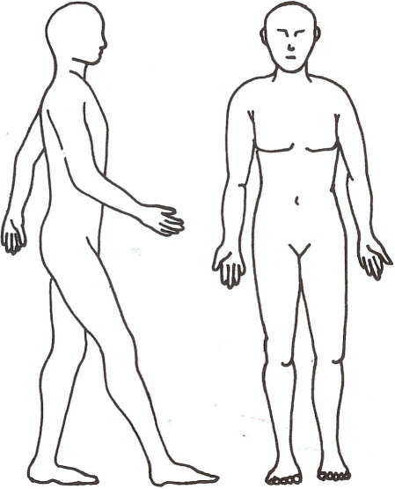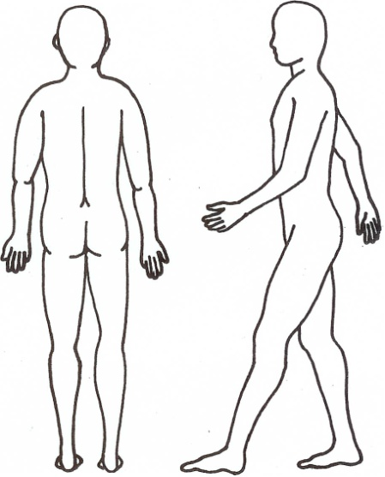

CIRCLE all that apply to your current symptoms. Quality of symptoms (What does it feel like?)
Sharp Shooting Stabbing Aching Dull
Stiffness Tightness Tingling Numbness

(3) Patient’s Name

TREATMENT BY OTHER DOCTORS FOR YOUR CURRENT SYMPTOMS/PROBLEMS
TESTS AND/OR PROCEDURES DATE OF TEST NAME OF DOCTOR

ACTIVITIES OF DAILY LIVING
How do your symptoms interfere with your ability to function? Circle or check whichever applies:

Getting out of a chair Mild Moderate Severe
Getting in/out of car Mild Moderate Severe
Going up/down stairs Mild Moderate Severe
Standing Mild Moderate Severe
Walking Mild Moderate Severe
Bending over Mild Moderate Severe
Exercising Mild Moderate Severe
Household chores Mild Moderate Severe
Lifting objects Mild Moderate Severe
Reaching overhead Mild Moderate Severe
Showering or bathing Mild Moderate Severe
Dressing myself Mild Moderate Severe
Lying down Mild Moderate Severe
Getting to sleep Mild Moderate Severe
Staying asleep Mild Moderate Severe

CURRENT MEDICATIONS
Please list all medications you are taking. Include prescribed drugs and over-the-counter drugs, vitamins etc.
Drug Name/Strength Frequency Name of Doctor prescribed
mg
mg
mg
mg mg

ALLERGIES
List anything that you are allergic to (medications, food, bee stings, etc) and how each affects you
Allergy Reaction

(4) Patient’s Name

PAST MEDICAL HISTORY (Please check all that apply)
AIDS or HIV Diverticulitis Leg/Foot Ulcers
Alcoholism Double Vision Liver Disease
Arthritis Fibromyalgia Loss Bladder/Bowel Control
Blood Clots Gout Lost Consciousness
Blood in Urine/Stools Heart Attack Lost/Gained Weight
Cancer Heart Murmur Osteoporosis
Coronary Artery Disease Hiatal Hernia Polio
Coughing up Blood High Blood Pressure Pulmonary Embolism
Cramping Legs/Arms High Cholesterol Reflux or Ulcers
Diabetes-Insulin Irritable Bowel Sleeping Disorder
Diabetes-Non-Insulin Kidney Disease Stroke
Thyroid Hyper/Hypo

PAST SURGICAL HISTORY
SURGERY/Year performed REASON FOR THE SURGERY

SOCIAL HISTORY
ALCOHOL USE TOBACCO USE DRUG USE
None Never Smoker Do you currently use street drugs?
Casual drinker Current every day smoker Yes No
Moderate drinker Current some day smoker If yes, please list
Heavy drinker Former Smoker

FAMILY HISTORY
Relative Age (if living) Illnesses Cause of death
Mother
Father
Sister 1
Sister2
Brother 1
Brother 2

(5) Patient’s Name

WOMEN
I realize that an X-ray examination may be hazardous to an unborn child and I certify that to the best of my knowledge I am not pregnant. Date of last menstrual period Initials
Comments

OTHER HEALTH FACTS Please add other information about your health that you would like the Doctor to know here:

ACKNOWLEDGEMENTS Please read each statement and initial your agreement.

I grant permission to be called to confirm or reschedule an appointment and to be sent occasional cards, Initials letters, emails or health information to me as an extension of my care in this office.

It is the practice of this office to provide chiropractic care in an “open adjusting” environment. “Open Initials adjusting” involves several patients being seen in the same adjusting room at the same time. Patients are within sight of one another and some ongoing routine details of care are discussed within earshot of other patients and staff. This environment is used for ongoing care and is NOT the environment used for taking patient histories, performing examinations or presenting reports of findings. These procedures are completed in a private confidential setting.

To the best of my ability, the information I have supplied is complete and truthful.
Initials

I understand and agree that health and accident insurance policies are an arrangement between my insurance company and myself-not between my insurance company and this office. I accept responsibility for payment for all services rendered regardless of what my insurance carrier pays.
Any balance unpaid after thirty (30) days from the last date of service, will be subject to a $5 billing fee or finance charges of 1-1/2% per month. Furthermore, I will be responsible for all costs of collection including reasonable attorney fees.

Signature Date

